Editorial Board:
Patrons:
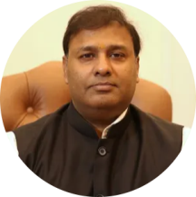 | Er. Pankaj Agarwal  Chancellor  SRMU, Barabanki-India
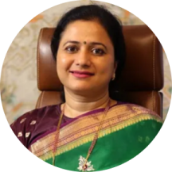 | Er. Pooja Agarwal  Pro Chancellor  SRMU, Barabanki-India

Editor-in-Chief
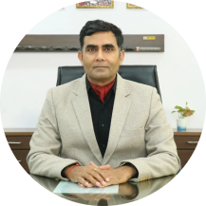 | Prof. (Dr.) Vijay Tiwari  Vice Chancellor  SRMU, Barabanki-India  vc@srmu.ac.in

Deputy Editors-in-Chief
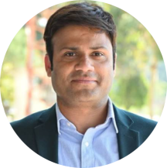 | Prof. (Dr.) Nabeel Ahmad  Director (Research)  SRMU, Barabanki-India  director.research@srmu.ac.in
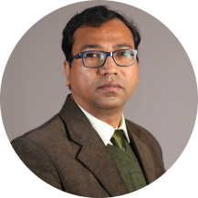 | Prof. (Dr.) Alkesh Agrawal  Deputy Director (Research)  SRMU, Barabanki-India  dd.research@srmu.ac.in

Associate Editors
Dr. Jay Kumar Pandey | Dr. Md. Saaquib Bin Reyaz | Dr. Mriyunjay Rai | Dr. Md. Zain
Dr. Devendra Singh | Dr. Garima Gupta | Dr. Rajeev Kumar | Dr. Sunil K Singh
Prof. (Dr.) Dilip Jaiswal | Dr. Md. Nadeem | Dr. Nitish Singh | Dr. Rahul K Vishwakarma

Advisory Committee
Prof. (Dr.) B. M. Dixit | Prof. (Dr.) Apurva Anand | Prof. (Dr.) Tabish Kidwai | Prof. (Dr.) R.S. Bajpai
Prof. (Dr.) Abhishek Saxena | Prof. (Dr.) Rajesh Porval | Prof. (Dr.) V. N. Pathak | Prof. (Dr.) R. G. Singh
Dr. Shobhit Sinha | Dr. Sadhana Singh

Advisory Committee (International)

